**Home work 2**

1. Express the vector (9; 6) as a linear combination of the vectors (1; 2) and

(1;-4).

Sol:

$$\left[\begin{matrix}1 & 1 \\ 2 & -4\end{matrix}\right]\left[\begin{matrix}a \\ b\end{matrix}\right]=\left[\begin{matrix}9 \\ 6\end{matrix}\right]$$

a+b=9

2a-4b=6

So : a=7 b=2

7 $\left[\begin{matrix}1 \\ 2\end{matrix}\right]+2\left[\begin{matrix}1 \\ -4\end{matrix}\right]$

1. Determine whether the vector x1 =

(2; 1;3) lies in the span of the vectors x2 = (1; 2; 3) and x3 = (2; 3; 1).

Sol:

Lie in span mean : it can be written as linear compination of them :

$$\left[\begin{matrix}1 & 2 \\ 2 & 3 \\ 3 & 1\end{matrix}\right]\left[\begin{matrix}a \\ b\end{matrix}\right]=\left[\begin{matrix}2 \\ 1 \\ 3\end{matrix}\right]$$

a+2b=2

2a+3b=1

3a+b=3

a=-4 b=3

but in 3rd equation that is not correct so it doesn’t lie in the equation

1. a:

v1 = [−2 3], w = [−8 12]

w=4[-2 3]=4*v1

b:

$$\left[\begin{matrix}2 & 0 \\ 0 & 2 \\ 5 & 0\end{matrix}\right]\left[\begin{matrix}a \\ b\end{matrix}\right]=\left[\begin{matrix}4 \\ -6 \\ 10\end{matrix}\right]$$

2a=4

2b=-6

5a=10

a=2 b=-3

w=2v1-3v2

1. 1) e

2) d

3) b

4) f

5) a

6) c

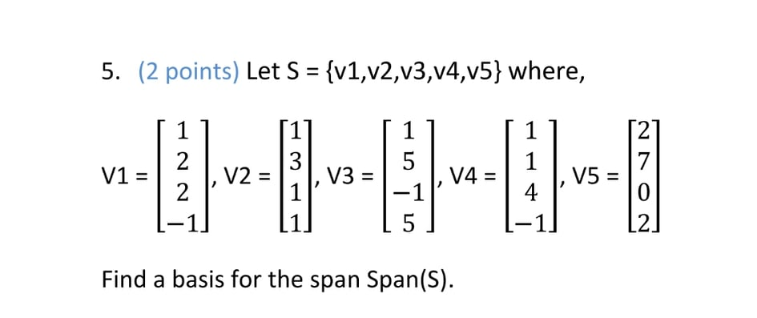

Sol:

By matrix reduction

$$\left[\begin{matrix}1 & 1 & 1 & 1 & 2 \\ 2 & 3 & 5 & 1 & 7 \\ 2 & 1 & -1 & 4 & 0 \\ -1 & 1 & 5 & -1 & 2\end{matrix}\right]$$

R2🡪-2R1+R2

and R3🡪-2R1+R3

and R4🡪R1+R4

$\left[\begin{matrix}1 & 1 & 1 & 1 & 2 \\ 0 & 1 & 3 & -1 & 3 \\ 0 & -1 & -3 & 2 & -4 \\ 0 & 2 & 6 & 0 & 4\end{matrix}\right]$

R3🡪R2+R3

And R4 🡪 -2R2+R4

$$\left[\begin{matrix}1 & 1 & 1 & 1 & 2 \\ 0 & 1 & 3 & -1 & 3 \\ 0 & 0 & 0 & 1 & -1 \\ 0 & 0 & 0 & 2 & -2\end{matrix}\right]$$

R4🡪-2R3+R4

R2🡪R3+R2

$$\left[\begin{matrix}1 & 1 & 1 & 1 & 2 \\ 0 & 1 & 3 & 0 & 2 \\ 0 & 0 & 0 & 1 & -1 \\ 0 & 0 & 0 & 0 & 0\end{matrix}\right]$$

R1🡪-R3+R1

$$\left[\begin{matrix}1 & 1 & 1 & 0 & 3 \\ 0 & 1 & 3 & 0 & 2 \\ 0 & 0 & 0 & 1 & -1 \\ 0 & 0 & 0 & 0 & 0\end{matrix}\right]$$

R1🡪-R2+R1

$$\left[\begin{matrix}1 & 0 & -2 & 0 & 1 \\ 0 & 1 & 3 & 0 & 2 \\ 0 & 0 & 0 & 1 & -1 \\ 0 & 0 & 0 & 0 & 0\end{matrix}\right]$$

From matrix the independents and who are basis is : V1,V2,V4